A0000-Eur-France-Paris Basin-Middle Paleolithic Period-Levallois Method-Scraper-Flint-100,000 BP-30,000 BP

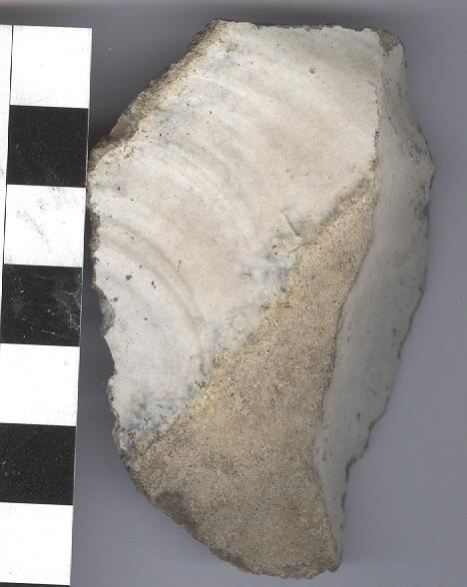

Fig. 1. Paris Basin-Middle Paleolithic Period-Levallois Method-Scraper-Flint-100,000 BP-30,000 BP

**Formal Label:** Paris Basin-Middle Paleolithic Period-Levallois Method-Scraper-Flint-100,000 BP-30,000 BP

**Display Description:**

This Paris Basin flint scraper with a blond to white patina dates to the Middle Paleolithic Period of the Mousterian type of industry using the Levallois method of flint knapping dating to 200,000 BP.

Mousterian is named for its type-site Le Moustier, a rock shelter in Dordogne, France (Chase and Dibble, 1987). The time-horizon of the Mousterian industry extends from ca 200,000 BP to 30,000 BP, roughly the rise and extinction of *Homo neanderthalensis* and the rise of *Homo sapiens sapiens.* The geographical range of the Mousterian industry extended from n Africa (Homo sapiens sapiens) to the Middle East (both *Homo sapiens sapiens* and *Homo neanderthalensis*, Shea, 2003; Tyron et al., 2006) and Europe (*Homo neanderthalens*is). The Paris Basin soil chemistry coats flint with a white to blond patina, which results from the adsorption of calcium carbonates on the cortex (external surface or rind) up to a depth of 0.5 mm over 200,000 years. The thickness of the patina on this specimen shows an age ca 200,000 BP.

**Accession Number:** A

**LC Classification:**

**Date or Time Horizon:** 100,000 BP-30,000 BP

**Geographical Area:** Paris Basin, near Ormesson, s of Paris

**Map, GPS coordinates:** [48°47′09″N 2°32′18″E](https://tools.wmflabs.org/geohack/geohack.php?pagename=Ormesson-sur-Marne&params=48.7858_N_2.5383_E_type:city%289937%29_region:FR-J)



**Cultural Affiliation:** Mousterian, *Homo erectus*.

**Medium:** Paris Basin Flint

**Dimensions:**

**Weight:**

**Condition: original.**

**Provenance: Excavated** under the auspices of CNRS, UMR 7041, Equipe d'Ethnologie préhistorique, MAE – 21 allée de l'Université, Hauts-de-Seine, 92023 Nanterre cedex, France.

**Discussion:**

The (2009) of an open-air site of Ormesson (Seine-et-Marne e France) dating to ca 29,000 cal. BP is related to a bison hunt and illustrates a late Mousterian habitation area. Mousterian remains include a lithic industry, a bone-working area, hearths and a red ochre processing station suggesting the application of these ground nodules to ritualized objects. In total this site provides a view of a series of integrated cognitive capacities of Mousterian *Homo erectus* during the Middle Paleolithic. This particular Levallois Method-Scraper is expertly flaked and illustrates this point!

**References:**

Bodu, Pierre; Salomon, Hélène; Leroyer, Mathieu; Naton, Henri-Georges; Lacarriere, Jessica; Dessoles, Mélina. 2014. “An open-air site from the recent Middle Palaeolithic in the Paris Basin (France): Les Bossats at Ormesson (Seine-et-Marne),” *Quaternary International,* 331: 39-59.